Wind Simulation:

**Introduction**

This report outlines the initial progress on developing a wind simulation system in Unity, inspired by the effect seen in Ghost of Tsushima. The goal is to create a visually appealing and functional wind system that enhances immersion and serves gameplay purposes.

**Scene Setup**

An initial scene has been created to serve as a testing ground for the wind simulation. This scene may undergo modifications as development progresses.

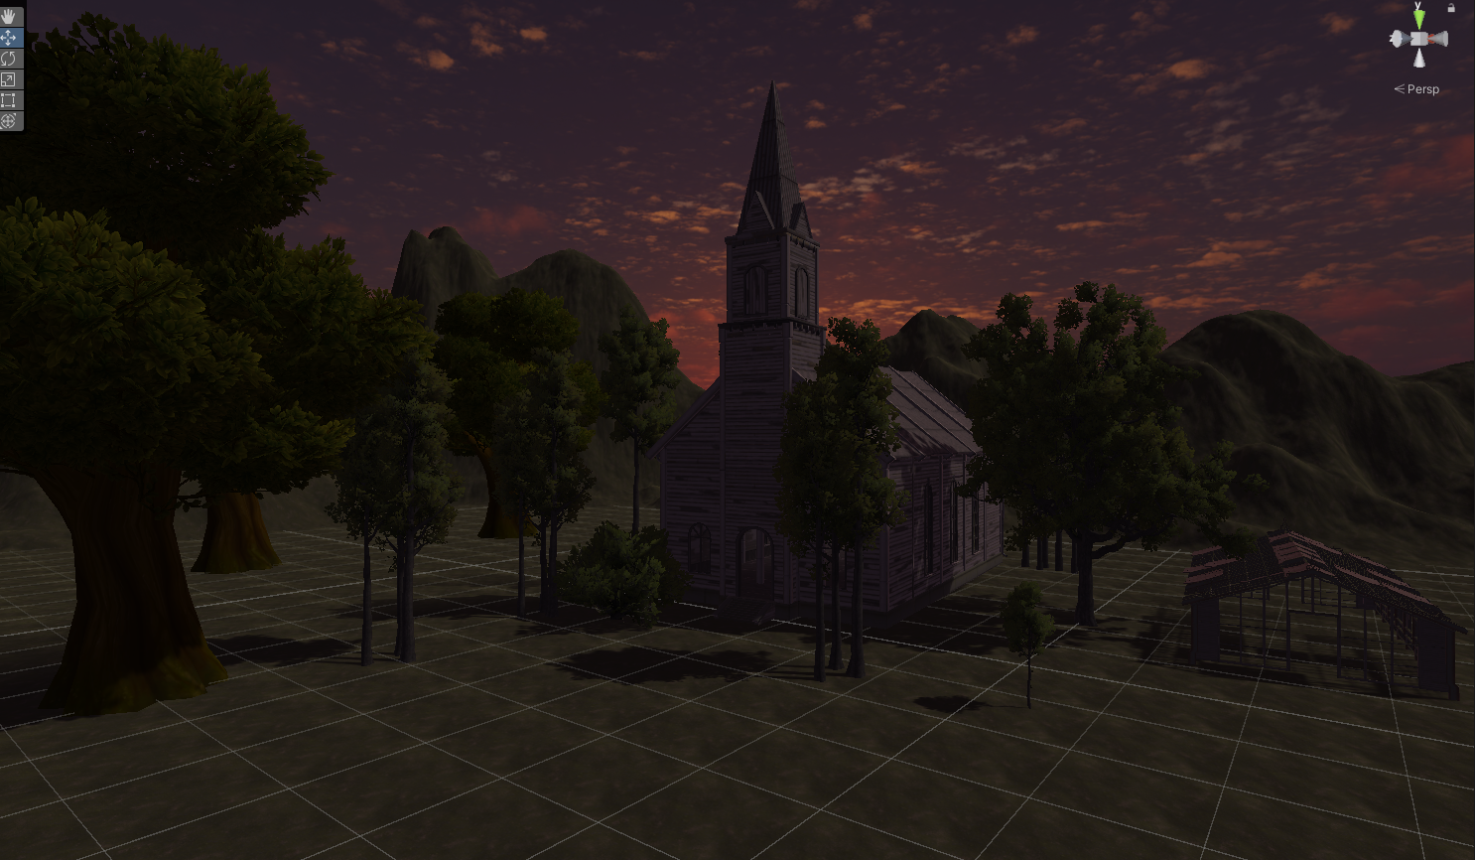**Wind Simulation Techniques (Proposed)**

* **Particle Effects:** Utilize particle systems to represent wind gusts and swirling effects. Leaves falling from tree and going with the wind.
* **Shaders:** Implement vertex shaders to dynamically manipulate the movement of vegetation (grass, trees) based on wind direction and intensity

**Next Steps**

* Research and implement particle systems for wind effects in Unity.
* Prototype shader manipulation of vegetation based on wind direction.
* Evaluate and refine the wind's visual impact(like fog).

**Challenges**

* Shader work
* Achieving realistic and dynamic wind behavior.

**Conclusion**

This initial report establishes a foundation for developing a wind simulation system in Unity that captures the essence of Ghost of Tsushima. The proposed techniques will be further explored and implemented, with a focus on achieving a balance between aesthetics, performance, and gameplay integration.